MINI PROJECT

TOPIC : School billing system

AIM:

The School billing system is executed and verified

ALGORITHM:

1. Start
2. Enter the  [category](https://www.google.com/search?q=category&spell=1&sa=X&ved=2ahUKEwiitrqf84nxAhWRheYKHW3CCN0QkeECKAB6BAgBEDE) if the user is a student or staff
   1. Student

2.1.1 Enter 2 for new user

2.1.2 Fill the details to be recorded in the array of structure and move to step 3

* 1. Staff

2.2.1 Enter 2 for new user

2.2.2 Fill the details to be recorded in the array of structure and move to step 3

3. Enter 1 for already registered user

3.1 Student

3.1.1 Enter the roll number and all the other details a printed using getinfo(); function

3.1.2 Enter the payment mode and move to step 4

3.2 Staff

3.2.1 Enter the ID and all the other details are printed using

Getinfo_staff() function and move to step 4

1. Enter 1 to exit and 2 to continue

4.1 if 2 call the function pointer (*user_existancefn_ptr)();

4.2 if 1 move to step 5

5. Stop

PROGRAM:

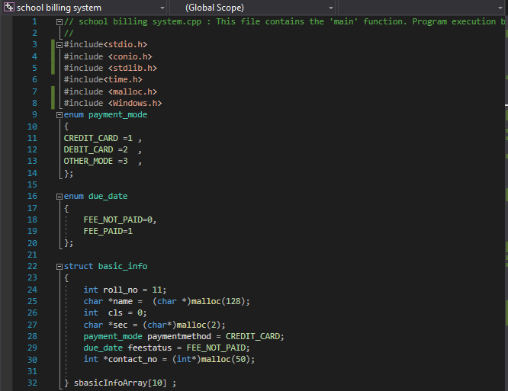

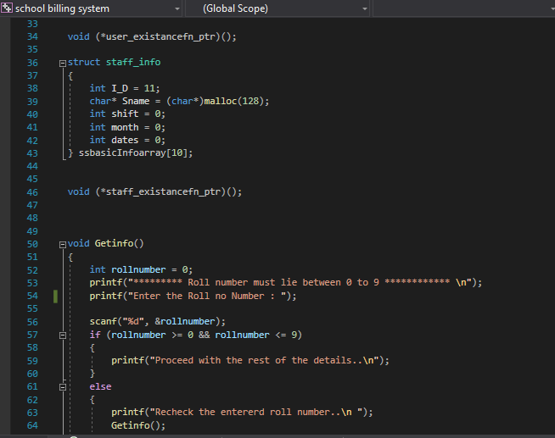

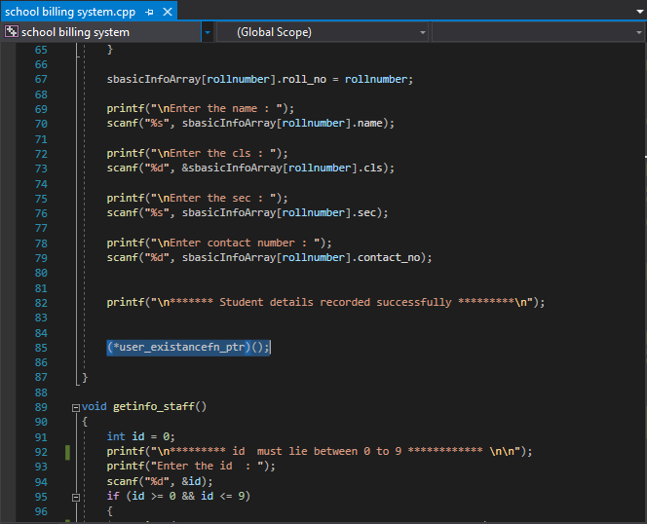

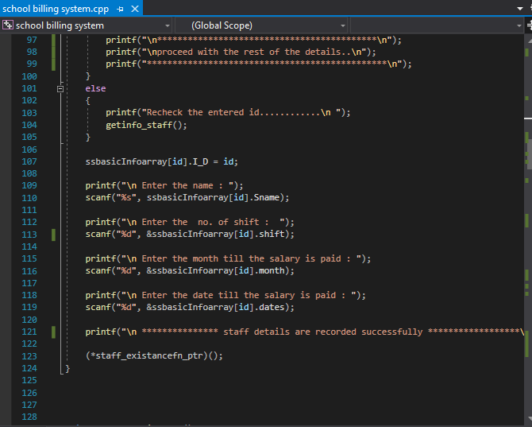

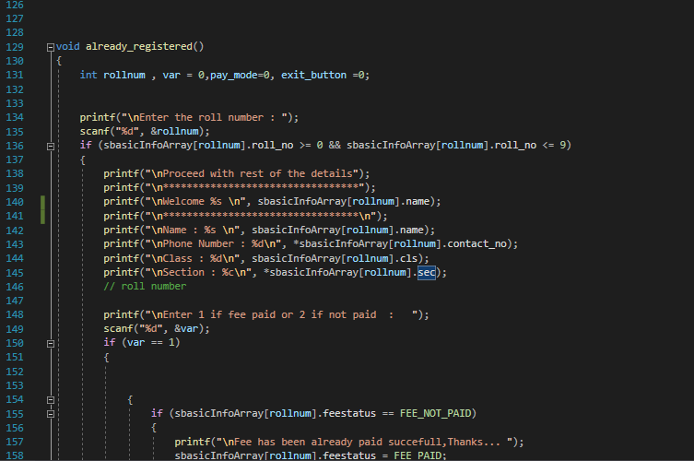

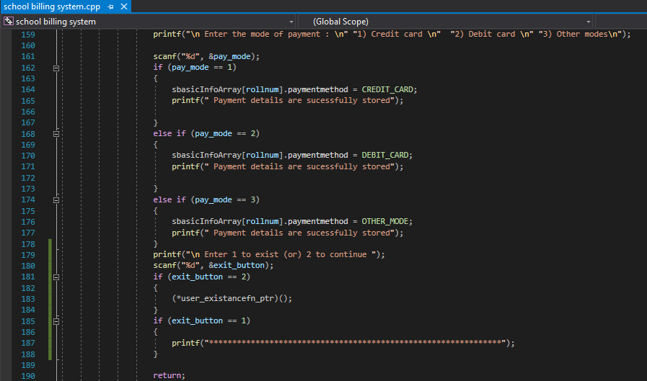

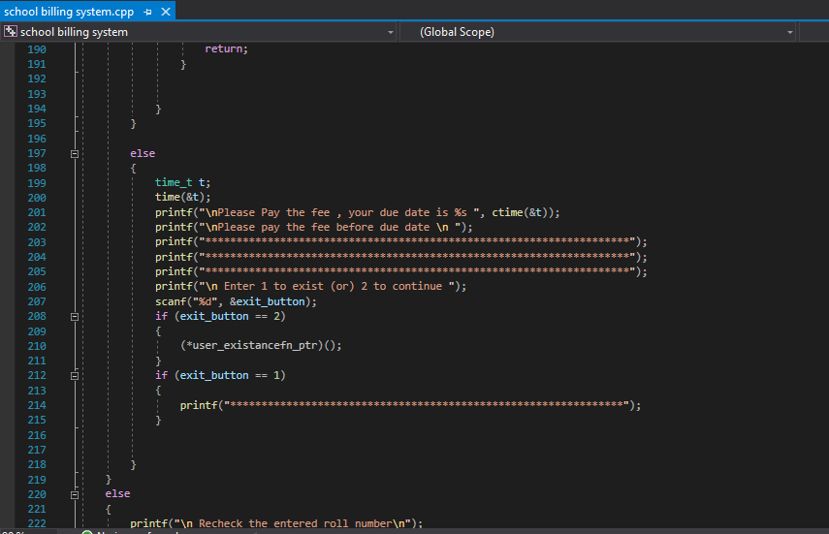

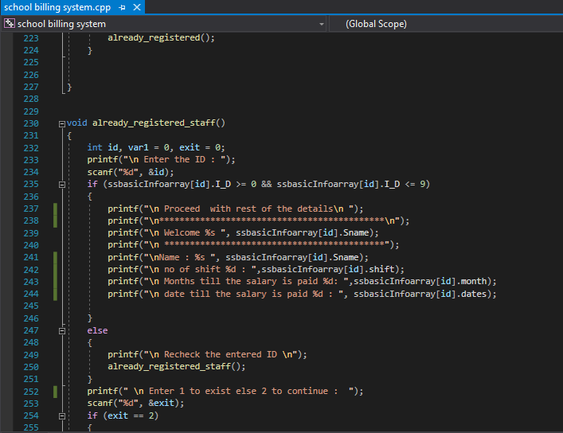

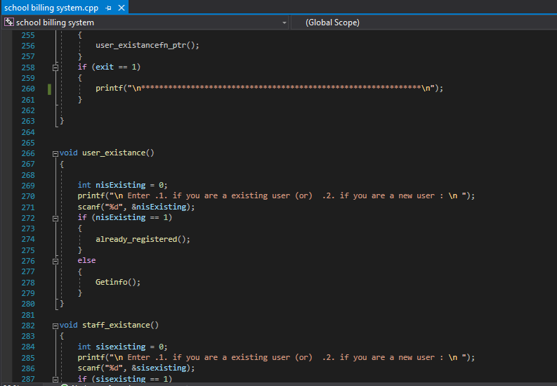

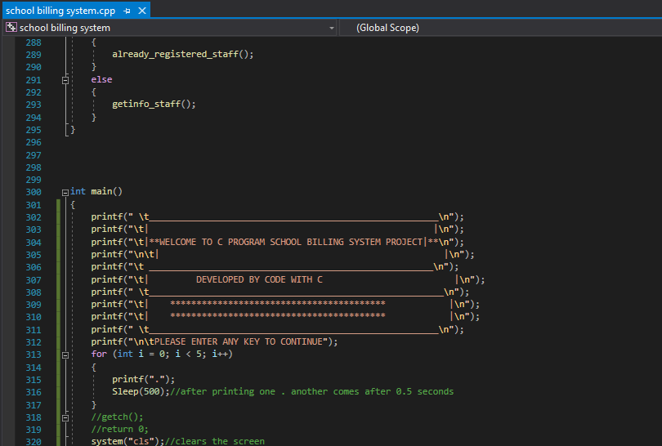

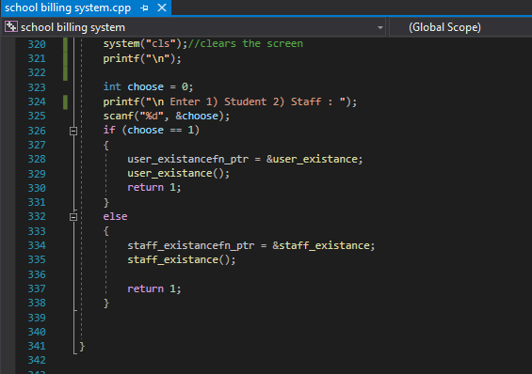

OUTPUT:

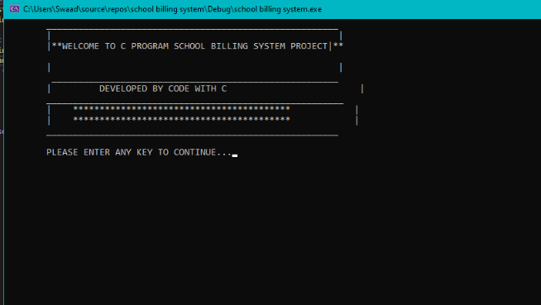

STUDENT

* Details are recorded form the user and stored in the array of structure

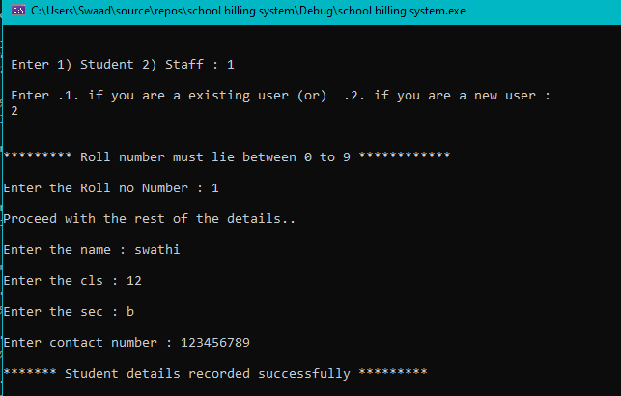

* Checking are the details recorded but entering the roll number and all the details basic details recorded are printed

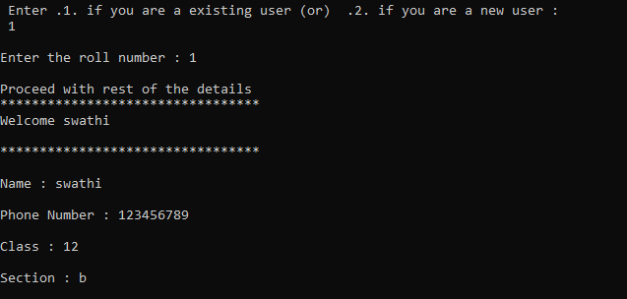

* Payment mode

Case 1:

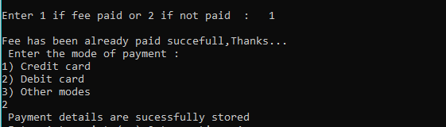

Case 2:

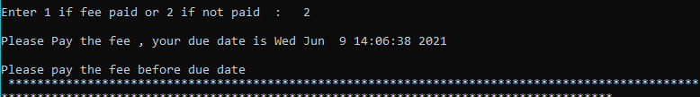

* Exit statments

Case 1:

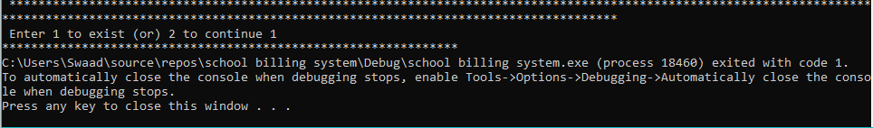

Case 2:

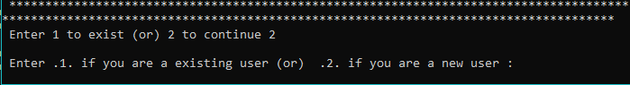

STAFF

* Details are recorded form the user and stored in the array of structure

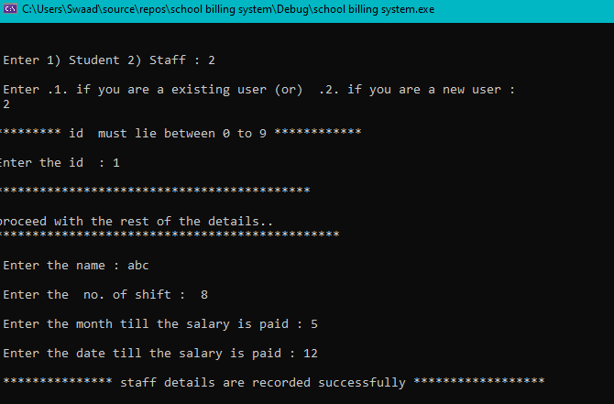

* Checking are the details recorded but entering the id and all the details basic details recorded are printed

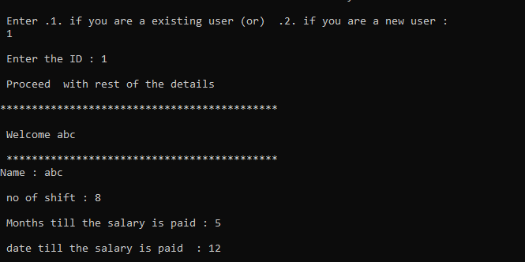

* Exit

